**What is Lent?**



***Lent lasts for the 40 days before Easter in the Christian calendar; it is a time of reflection for many Christians as they prep*are to remember** ***and the death and celebrate resurrection of Jesus Christ.***

What is Lent? Lent lasts for 40 days. During lent we are encouraged to do 3 important things: Give something up or do something extra,

Say some extra prayers, and donate money or something else like your time or some of your possessions to those who have less than you.

The arrival of Lent is characterised by pancakes! Shrove Tuesday, a day highly anticipated by all pancake lovers, is traditionally a day of preparation before the season of Lent begins. The 40 days of Lent represent the [40 days that Jesus spent in the wilderness](https://www.biblegateway.com/passage/?search=Luke%204%3A1-13) at the start of his ministry. Jesus fasted during his time in the wilderness, and so Christians identify with his suffering by abstaining from particular foods during this time, including meat, fish, milk and egg products. This is why we traditionally eat pancakes because we use milk fat and eggs to make them. It’s a final family treat before we start Lent!

Shrove Tuesday gets its name from the ritual of ‘shriving’. This 1,000 year old practice involves a person confessing their mistakes, and receiving absolution for them before Lent begins.

Starting Lent

Lent begins on Ash Wednesday, a day saying sorry for the things we have done that are wrong – we call these things sins. Many Christians will attend Lent services and Mass, and be marked with a cross of ashes on their forehead. This is a sign of mortality, based upon the idea from the book of Genesis that humankind came into the world from dust and will return to it. It is a time to express sorrow over sin, and a reminder that Jesus brings freedom from sin. The following 40 days are an opportunity to remember that Jesus came to earth to be our friend, we use the time to grow closer to him.

**Lenten Promises**: In our school we all make our Lenten promises which we try hard to keep for all of the season of Lent.

**Mothers’ Day** always falls on the fourth Sunday of Lent, this is when we celebrate our mums and thank them for all the love and care they give to us, lots of people also thank other people who care for them too like Nans, Aunties and neighbours. Mothering Sunday is thought to have started in the olden days when people returned to their mother church, typically a main church or cathedral of the area. Later on it was a special Sunday in the year when servants were allowed Mothering Sunday off to return home to their mother church and would often take a rare opportunity to see their families.

Holy Week

Holy Week begins with Palm Sunday, a day which commemorates Jesus’ triumphant procession into Jerusalem on a donkey. In our churches people are given palm crosses, whilst others wave palm branches. These are blessed, sometimes the people have a special service outside the church then they process into the church carrying their palms.

The Thursday before Easter is Holy Thursday, or Maundy Thursday. It is a reminder of the last meal Jesus ate with his disciples, washing their feet and leading them in the first ever Eucharist. He foretold his death; drawing a direct parallel between the bread and his body, and the wine and his blood. The following day is Good Friday, a day when we remember Jesus’ death on the cross. It is a day of mourning, when we remember the suffering and pain of Christ. The service on this day provides an opportunity for solemn reflection.

**Easter Sunday**

**On Easter Sunday, the Church celebrates Jesus' resurrection. Fasts are finished and we celebrate with delicious Easter eggs! Churches will light a paschal candles to represent the eternal presence of Jesus, as he rises from the dead. The Mass on Easter Sunday is a joyful one for everyone, the church will be filled with flowers and everyone is happy – Jesus has Risen from the Dead! The altar cloths and the priests’ robes are white – during Lent they are purple.**

**The great feast of Easter is very important in our church calendar – if we prepare well during Lent our Easter celebrations will be more meaningful and joyful.**

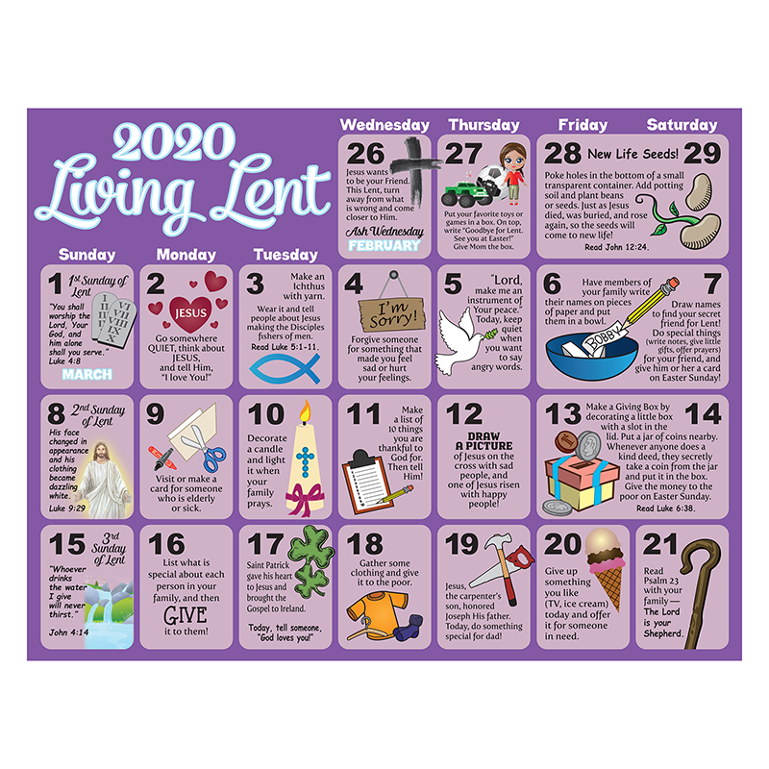The

